General usage flow (from empty)

Add items into inventory from the “Add to inventory” tab. New rows of textboxes will be created when you press tab if all the boxes have something in them. The items will be added to the inventory table, and the add tab will be cleared displaying a success message. If a box has an unaccepted value it will be highlighted. If you start typing in the name box and the inventory contains something that starts with that string, a text box will appear with the full name. Press enter and it will auto fill the textboxes, except quantity. This will update the suggested item with the values you give it and up the quantity by however many you enter.

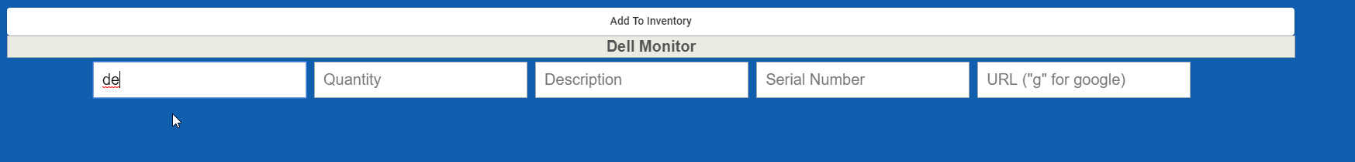

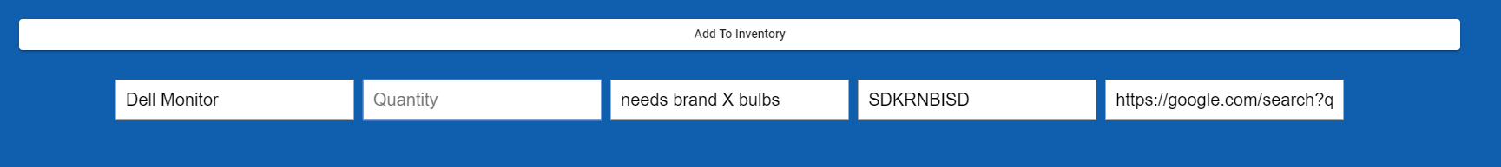

In the inventory you can queue an item to send it into the queue of items going out. Clicking the queue button in the “Actions” column sends one and only one to the queue. The thought process here was that you might be sending out 3 monitors but to different locations so if all 3 were in one entry you wouldn’t be able to split them up. With that you can also decommission an item. Clicking the decommission button will prompt you asking how many you want to send to the decom table, and any notes about it. The number you type must be less that or equal to the quantity remaining in the inventory. It will then subtract the number you give it from the quantity and add that many to the decom table. The color of the quantity scales down by (quantity / last restock quantity) \*100. Lastly, you can use the reorder button to pull up a new tab with the URL provided when the item was added. At the bottom of the inventory typescript file there is a commented line, <app-scan>, uncomment that to show the mass import thingy.

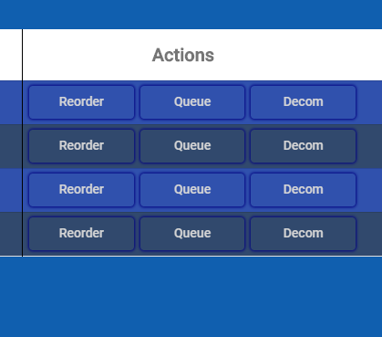

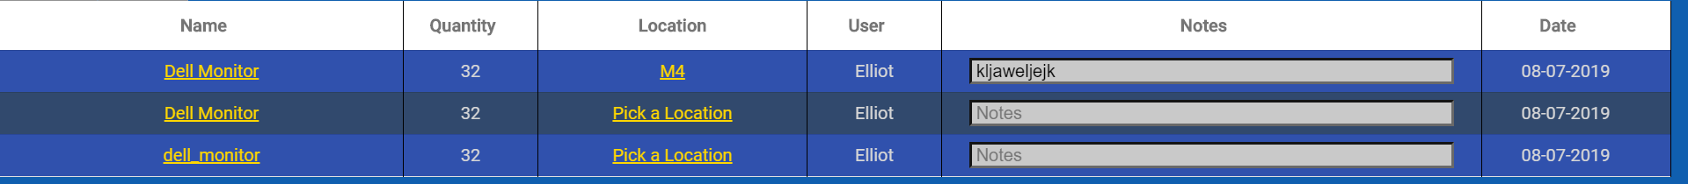 When an item is queued it shows the date it was added to the queue, and the user who queued it. To send something into deployment you must pick a location. Notes are optional. To send something into deployment click the name of the item, which is in gold and underlined.

Once an item is in deployment your options for it are changing its location via the Edit Mode toggle, and decommissioning and inventorying from the Actions column buttons. Decommissioning here is the same as doing it from the inventory. The “inventory” button here does the same thing as decommissioning except it adds it sends it back to the inventory.

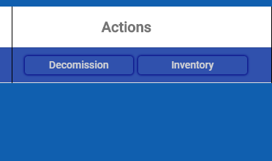

The bottom of the inventory page currently has 2 buttons on it. The Mass Delete and Edit Pins buttons on inventory must be clicked while holding control. There is one more button on top of the page to log out which simply clears the cookie of who’s logged in and reloads the page. The log out button does not require control to be held down.

Helpful links:

CRUD: <https://angular-templates.io/tutorials/about/angular-crud-with-firebase>

Deleting data: <https://firebase.google.com/docs/firestore/manage-data/delete-data>

Adding data: <https://firebase.google.com/docs/firestore/manage-data/add-data>

If you’re replacing firebase config you need to change in app-component.html, environment.prod.ts, and environment.ts